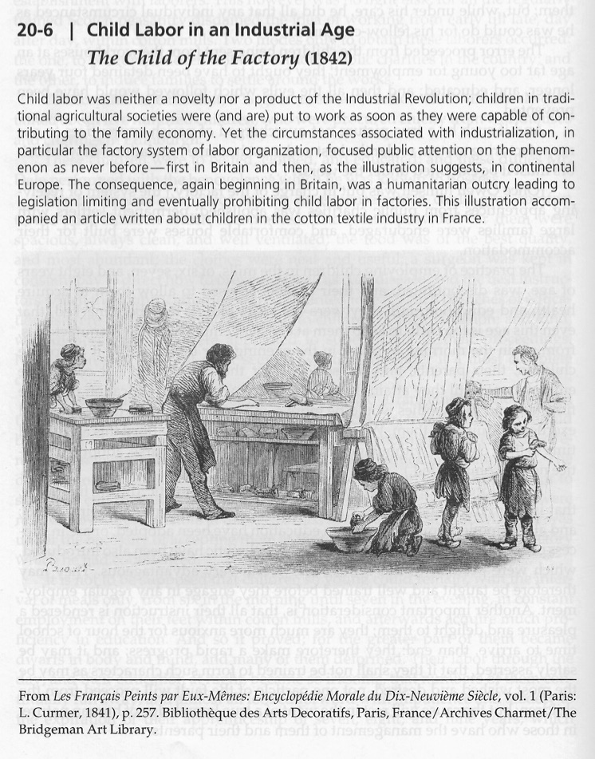

Reading Questions

- On what grounds might contemporaries (colleagues), including many members of the working class, have defended child labor?

- Are all of the children depicted in the illustration actually working? If not, then why might they be in the factory?

