Analyzing Social Darwinism
Directions:
Read the poem and the view the political cartoon below then answer the questions that follow?

Document 1:

Take up the White Man’s burden-
Send forth the best ye breed-
Go bind your sons to exile-
To serve your captives’ need;
To wait in heavy harness,
On fluttered folk and wild-
Your new-caught, sullen peoples,
Half-devil and half Child
Take up the White Man’s burden-
The savage wars of peace-
Fill full the mouth of Famine
And bid the sickness cease;
And when your goal is nearest,
The end for others sought,
Watch sloth and heathen Folly
Bring all your hopes to nought.

- Rudyard Kipling,
“The White Man’s Burden,” 1899

Document 2:
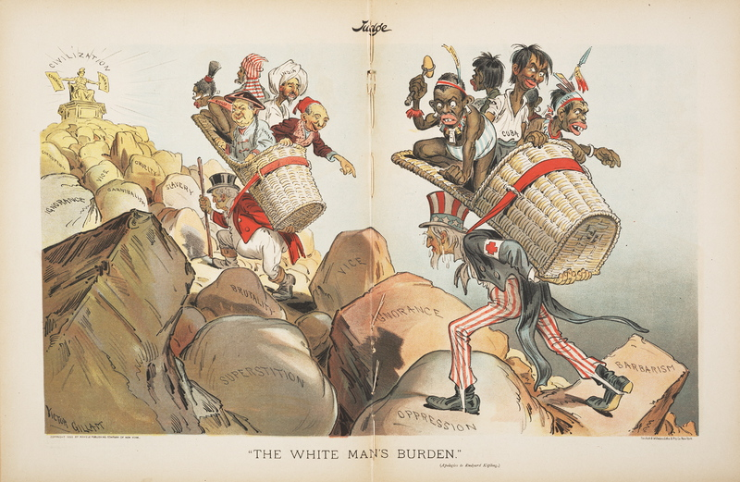

Analysis Questions:
- What is the “white man’s burden” referred to by Kipling in document 1?

- Briefly describe what you see in document 2.

- Who do the two individuals carrying the baskets represent? Why? (Hint: think about what you read in the notes)

- Who do the individuals in the baskets represent?

- Where are the two carrying the baskets taking those on their backs? Why?

- How does the poem and the image represent ideas of Social Darwinism?

