Analyzing Political Cartoons in the Age of Absolutism
Directions:
Complete a brief analysis of each image that follows. For your analysis determine what the image is saying about the role of the monarch and the citizens. Bullet points are fine here. After you have analyzed each image complete the overview questions at the end.

Image 1:
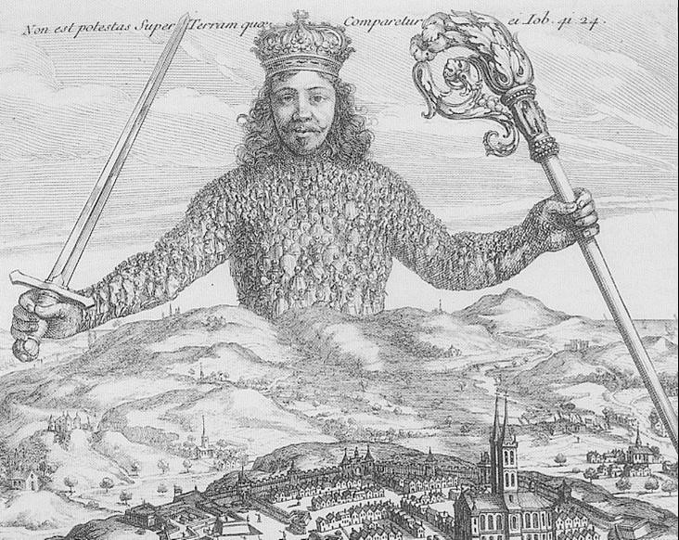
Analysis:

Image 2:
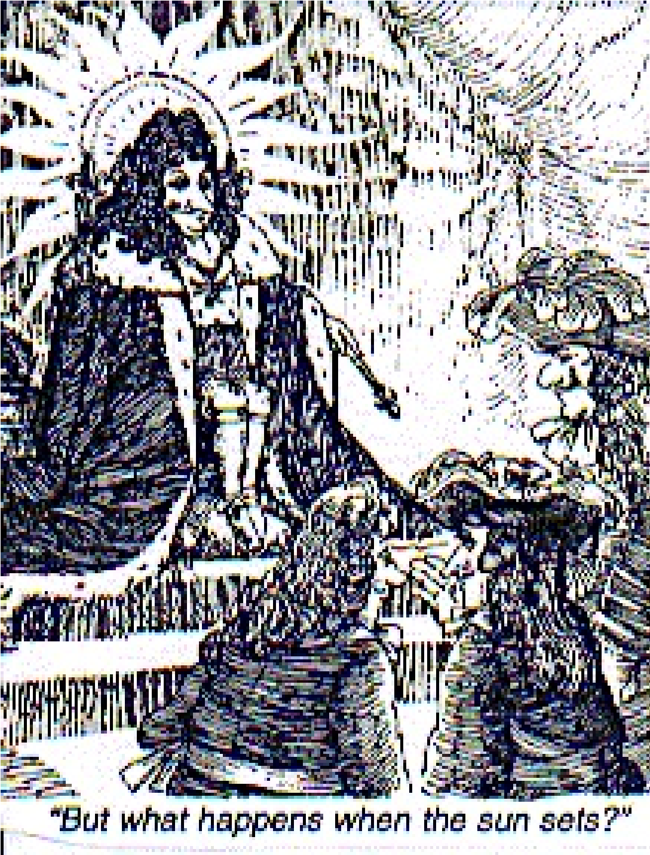
Analysis:

Image 3:
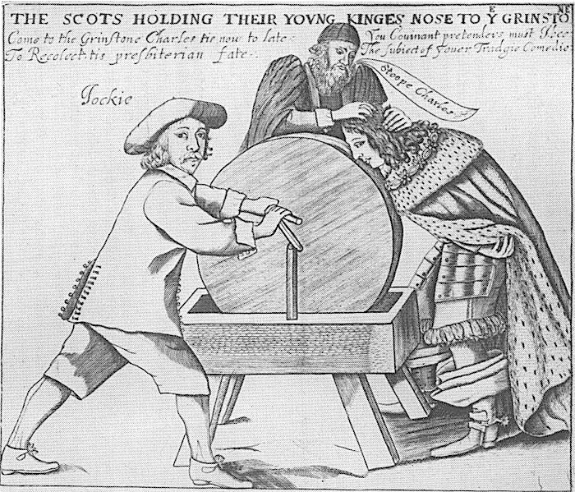
Analysis:

Image 4:

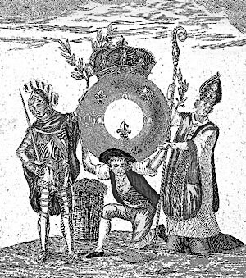
Analysis:

Overview Questions
- Based on what you have deduced from the cartoons, the lecture, and textbook what are the common characteristics of absolute monarchs?

- How are the monarchs depicted in the images? How are the common people depicted? Explain the difference.

- Based on your understanding of absolute monarchies provide a explanation of the benefits and the issues that are associated with this form of government.

- What do you think will be the long term consequences of the Age of absolutism?

